# Installation Guide

To run this script we need to have the underlying dependencies listed under “To run the scripts you need:”. Links have been provided. Let us start by clicking on “Python 2.7”

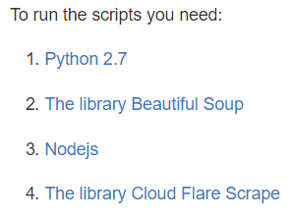

On the download website let us click on “Download Python 2.7.11”

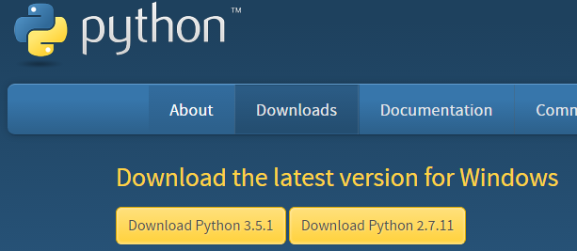

Personally I use chrome, which will show the downloaded item in the bottom left of the screen. If you are using a different browser the location will be different. Nevertheless, once the file finishes installing click on it to run it.

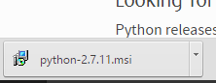

Go through the installation. Once done click Finish.

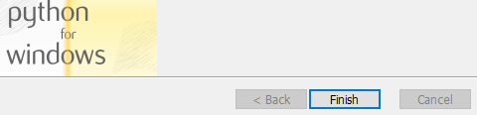

Python should now be installed on your computer. However it is not ready to use yet. Let us right click on “This PC”/”Computer”/”My Computer”. And select Properties

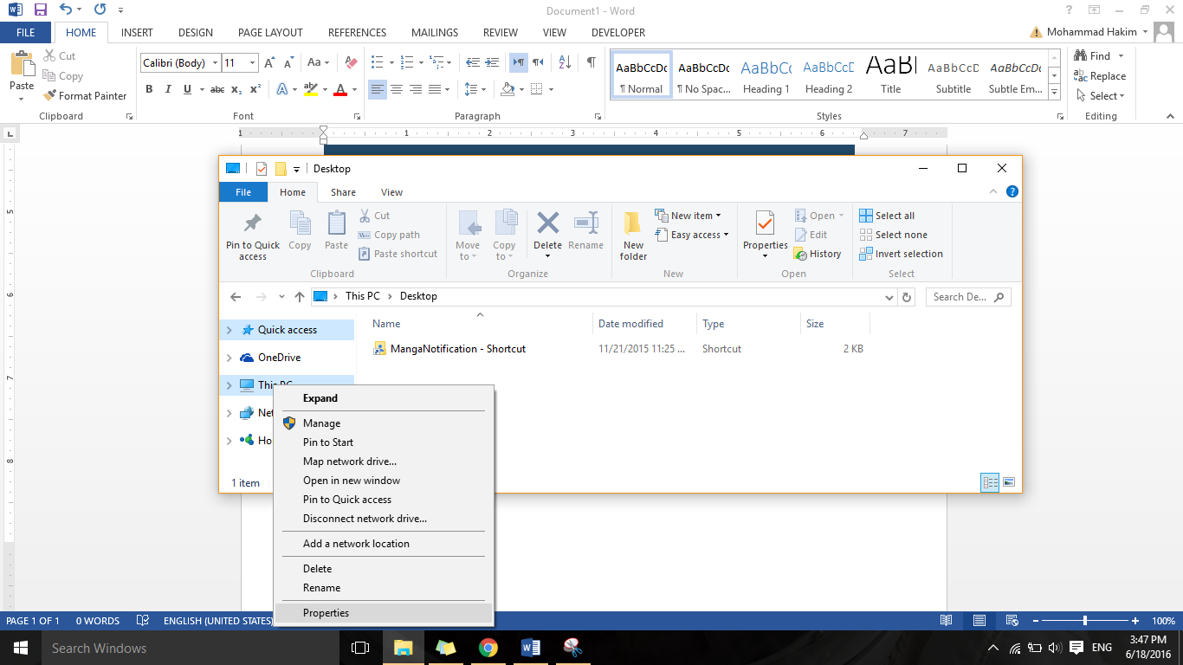

In the window that appears select “Advanced system settings”.

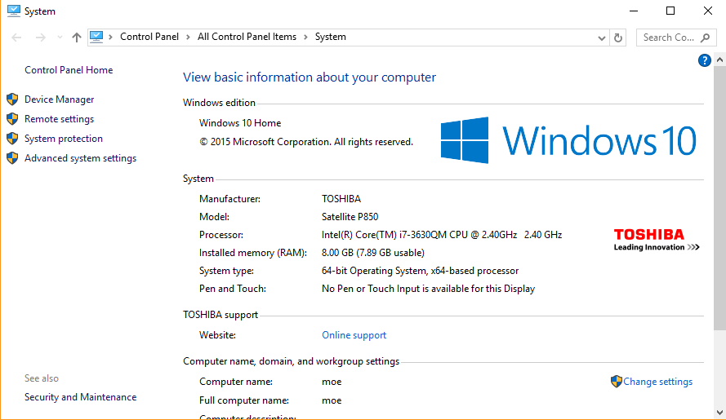

Under the “Advanced” tap select “Environment Variables…”

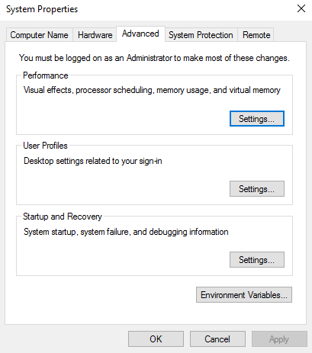

In the bottom part of the window which appears under “System Variables” locate “Path”. Click on it once to select it. Then choose “Edit…”

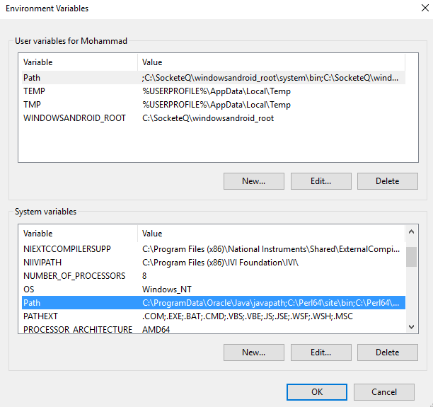

In the new window which appears select “New”

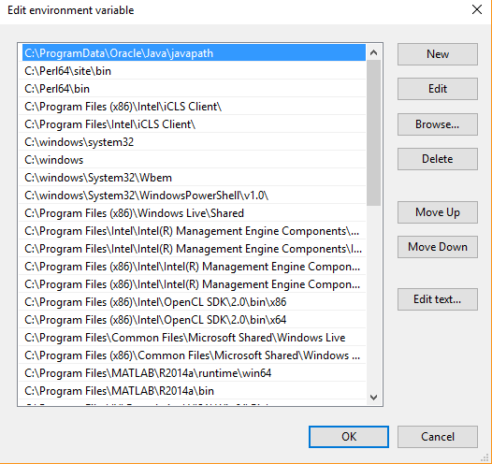

This will add a new line to the list and move your cursor into it.

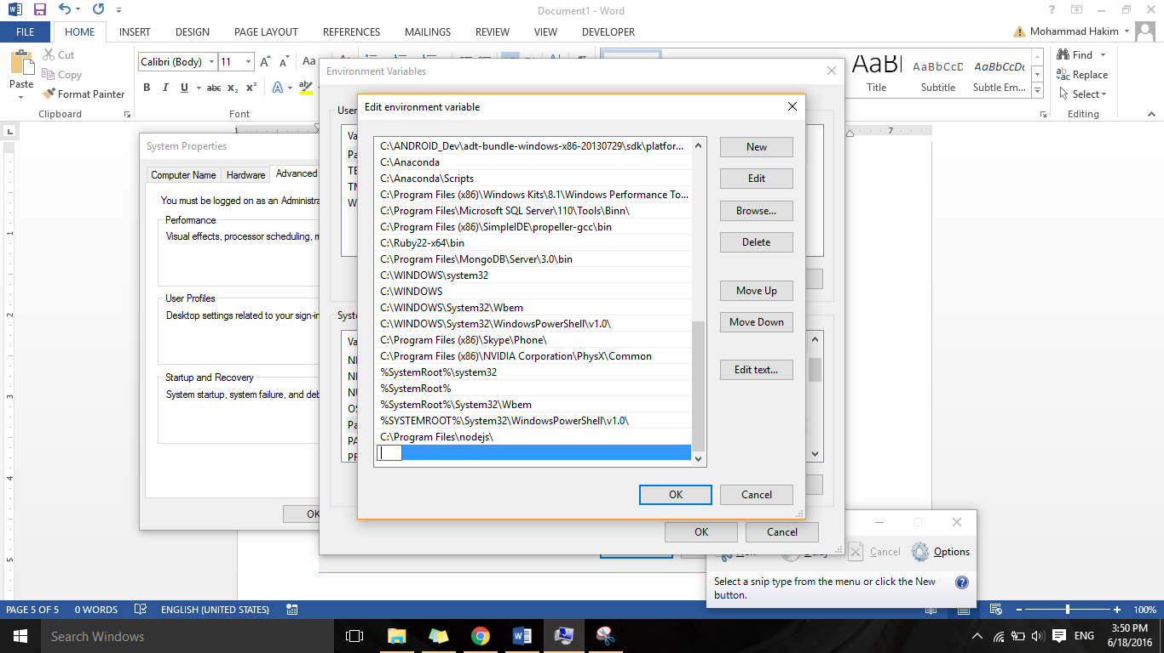

Enter in the location of where Python was installed. The default location is “C:\Python27”. Click OK until all the windows we opened (3) are gone.

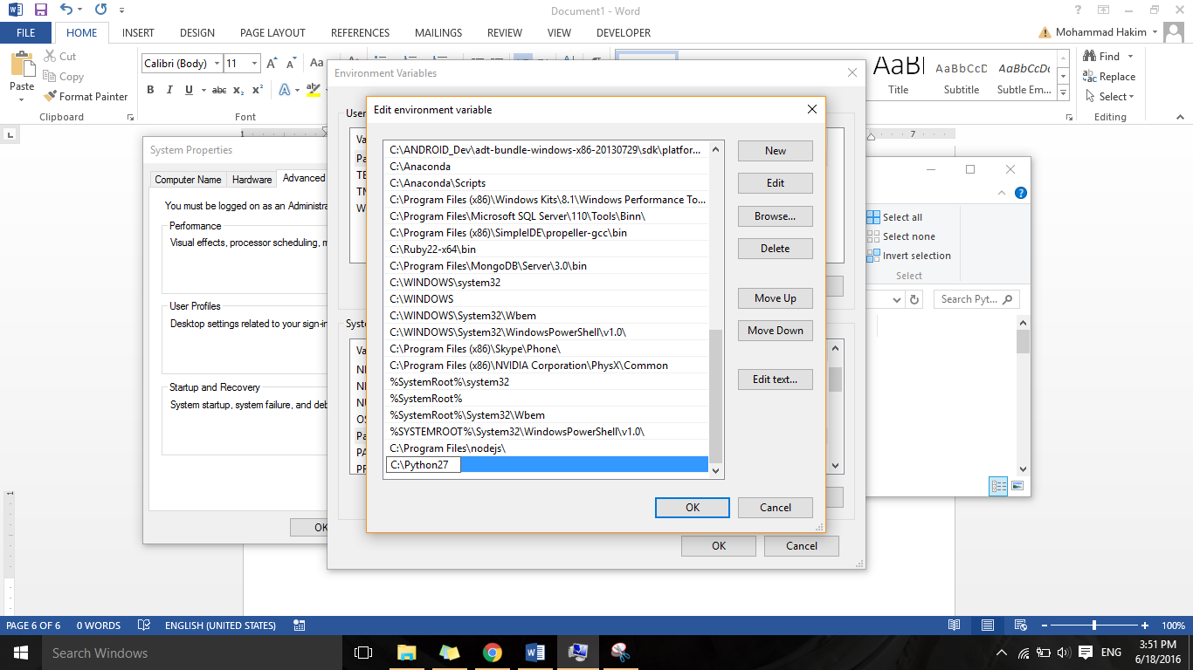

Now let us test our new toy. From the Start Window open up “Command Prompt”. Here I simply searched “cmd”

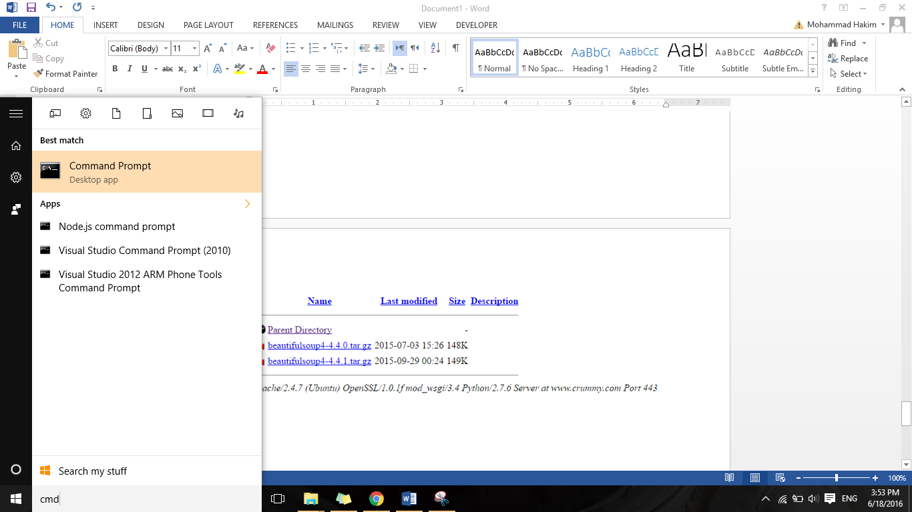

This will open up the command window/terminal.

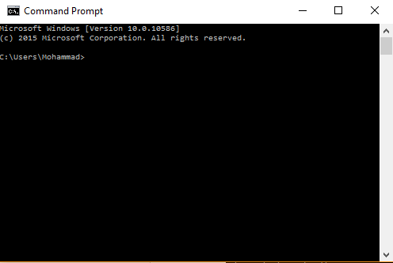

In the line which appears type in “python” and hit enter. If python has been correctly installed you should see something which looks like this. Notice the “>>>” which are prompting you to enter a python code.

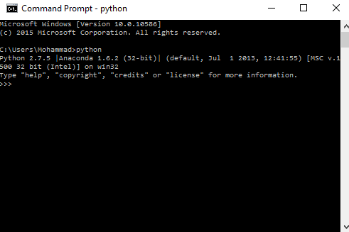

Now that we have python let us move on to installing Beautiful Soup. When at the website click on “Download”.

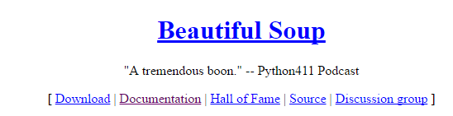

The website will tell you what the current release is. Click on it.



This will show us a directory of different versions of the library. Since the website told me the most recent one is “4.4…”, that is where I’ll go.

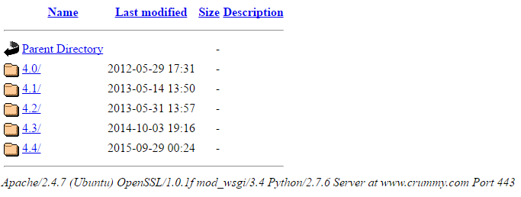

Now I will download “4.4.1” which the website originally stated.

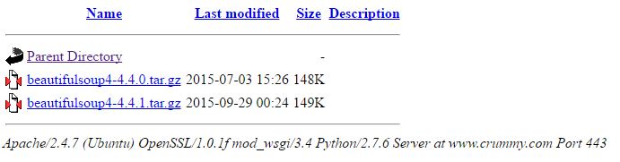

Locate the file which we have just downloaded. And extract it. I personally use WinRAR. Use whatever you wish. Perhaps you prefer 7zip.

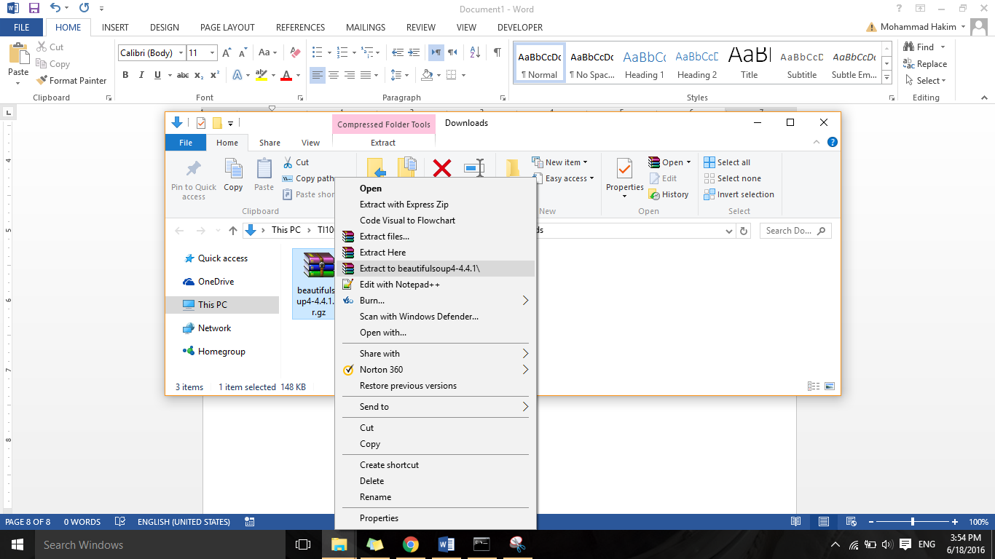

Once the folder is extracted go into it until you see the setup.py file. Note down the location of the folder. We will need it for the next step.

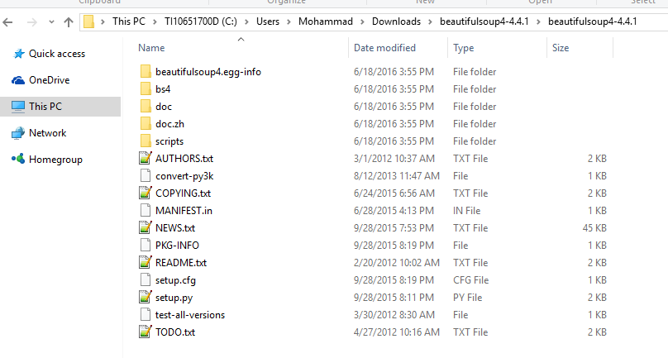

Now let us go back to the Command Prompt.

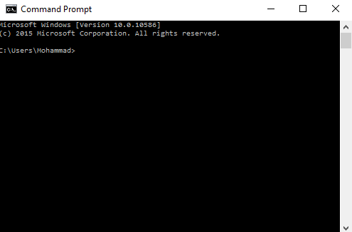

In the command prompt let us “cd” (change directory) into the location at which we have extracted the installing folder of the Beautiful Soup library (You can use copy paste here. Only to paste you must right click and then select “Paste”).

In my case the location is “C:\Users\Moammad\Downloads\beautifulsoup4-4.4.1\beautifulsoup4-4.4.1”. Hence the command I will enter is “cd C:\Users\Moammad\Downloads\beautifulsoup4-4.4.1\beautifulsoup4-4.4.1”

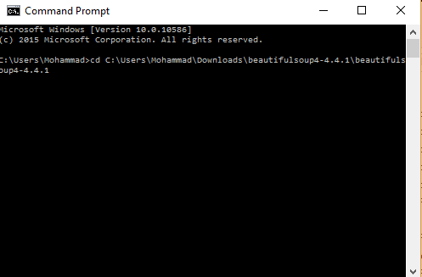

From there enter the command “python setup.py install”. This will add the library/package to Python.

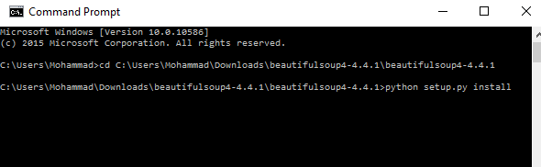

Once done let us invoke python by entering “python” into the “Command Prompt”



And try importing the library by typing “from bs4 import BeautifulSoup” (This is case sensitive). If we have installed the package correctly the Python interpreter will not complain.

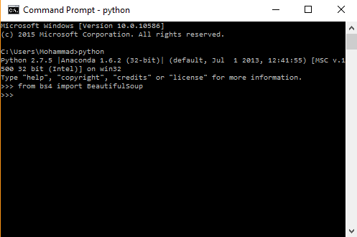

Moving on to installing Node. This one is easy. Just click on the “Windows Installer”

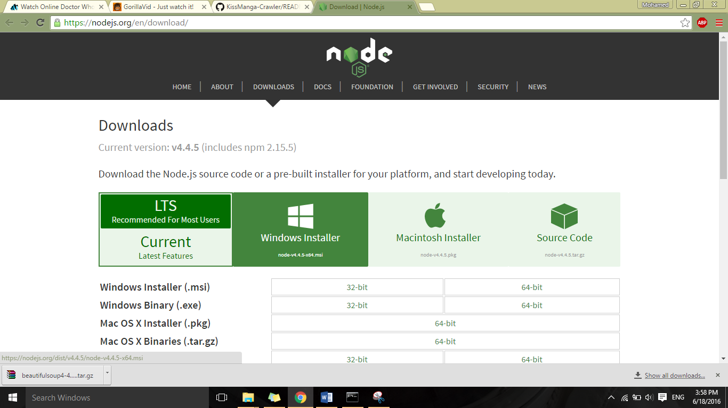

Run the downloaded file

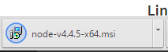

Go through the installation.

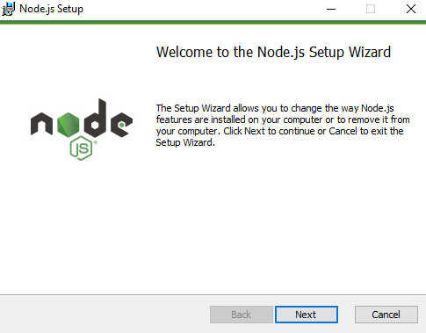

And once done click “Finish”.

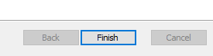

To test it go to the “Command Prompt” and enter “node”. Note the “>” which prompts you to enter NodeJS code.

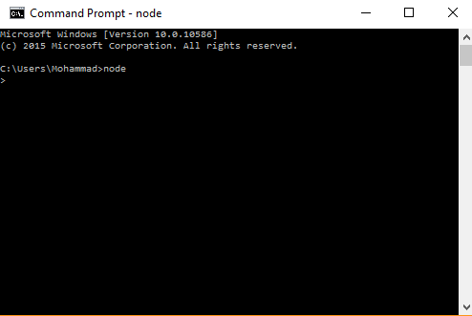

Now let us install the final dependency. From the GitHub repository we can download the zipped folder. Under “Clone or download” and then “Download ZIP”.

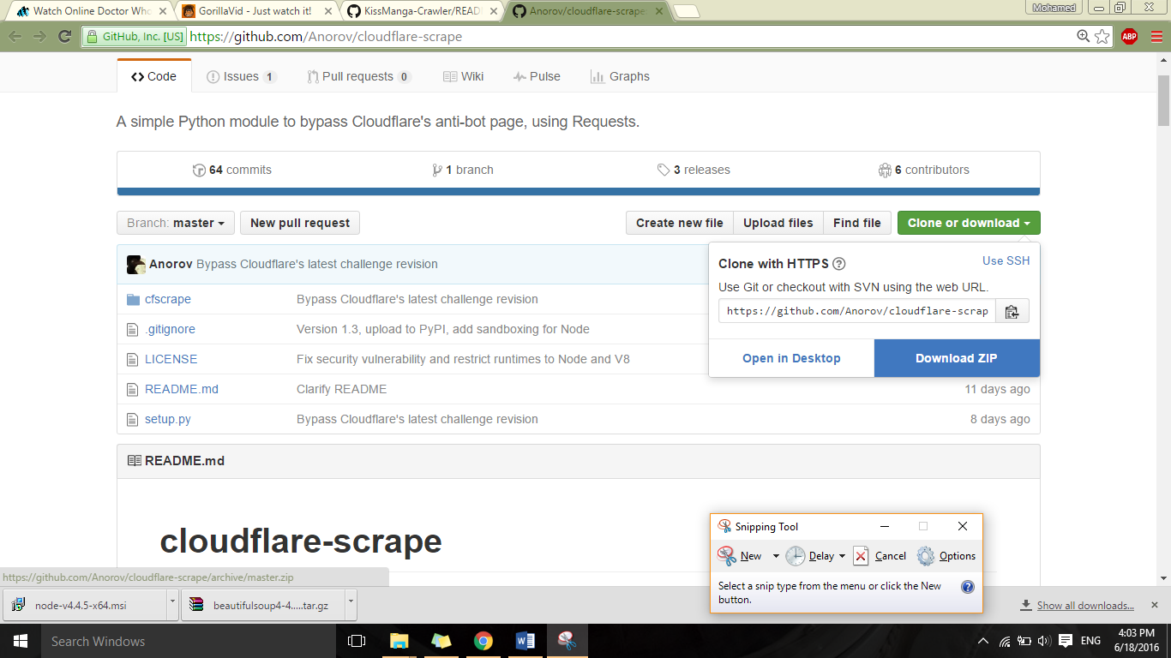

Extract the folder.

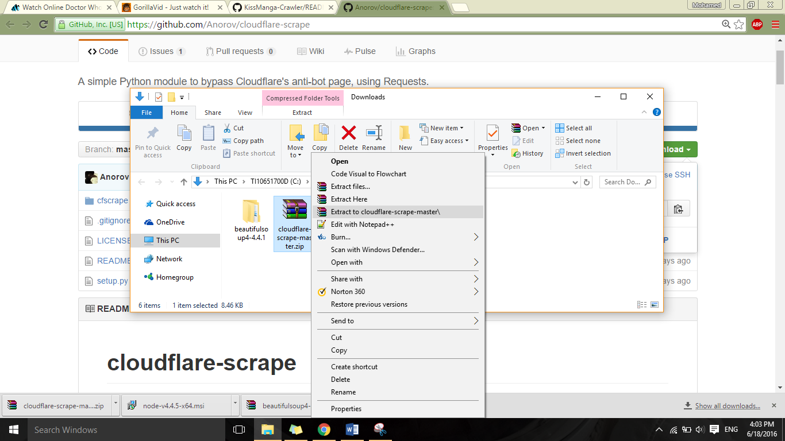

Locate the directory in which “setup.py” resides.

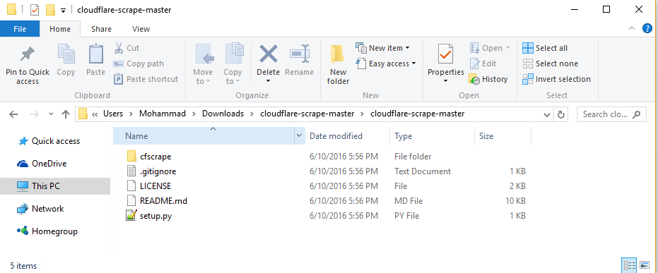

From the “Command Prompt install” it.

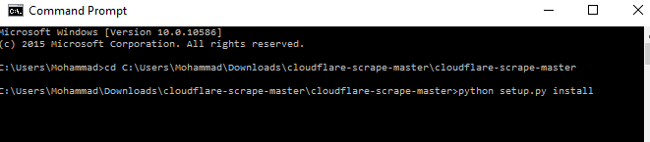

And then test it by invoking python then using the command “import cfsrape”

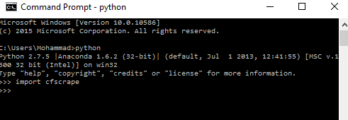

Now we are ready to run the code! Let us get a zipped copy.

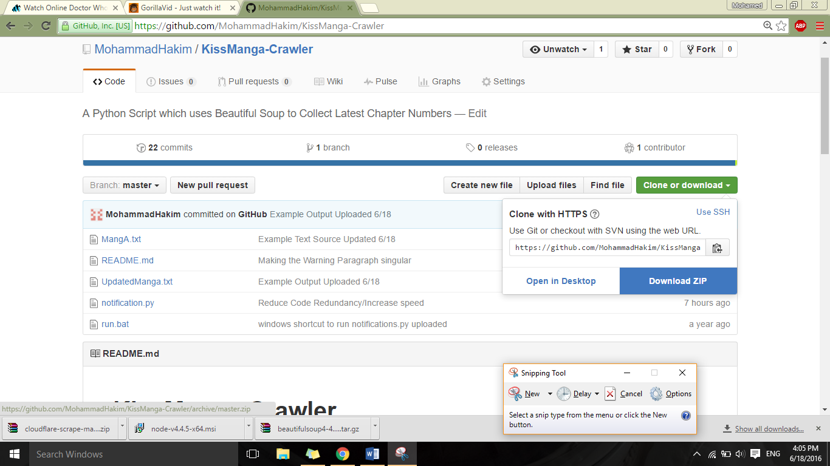

Extract it.

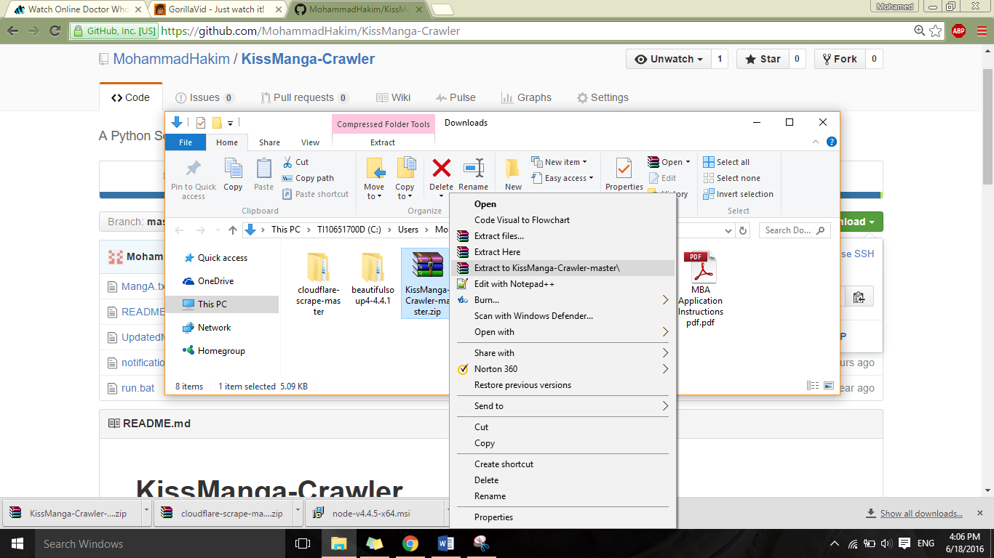

Double click on “run.bat” to see magic happen.

